# ITTS_inf.dll parameter definition

Command Table

|  |  |  |  |  |  |  |  |  |  |  |
| --- | --- | --- | --- | --- | --- | --- | --- | --- | --- | --- |
| **P1 (Min)** | **P2 (Max)** | **P3 (command)** | **P4**  **( INF File Name )** | **P5**  **(section Name)** | **P6**  **(Indication)** | **P7**  **(data)** | **P8**  **Default Value** | **P9**  **String Process** | **P10**  **Debug**  **(show status on AP)** | **Remark** |
|  |  | **01**:WriteInteger | INF File Name | Section Name | Indication  (IDx1) | Data  (12345) |  | String Process | debug |  |
|  |  | **11**:ReadInteger | INF File Name | Section Name | Indication  (IDx1) |  | Default Value  (12345) | String Process | debug |  |
|  |  |  |  |  |  |  |  |  |  |  |
|  |  | **02**:WriteFlaot | INF File Name | Section Name | Indication  (IDx1) | Data  (1.2345) |  | String Process | debug |  |
|  |  | **12**:ReadFloat | INF File Name | Section Name | Indication  (IDx1) |  | Default Value  (1.2345) | String Process | debug |  |
|  |  |  |  |  |  |  |  |  |  |  |
|  |  | **03**:WriteString | INF File Name | Section Name | Indication  (IDx1) | Data  (xxx12345) |  | String Process | debug |  |
|  |  | **13**:ReadString | INF File Name | Section Name | Indication  (IDx1) |  | Default Value  (xxx12345) | String Process | debug |  |
|  |  |  |  |  |  |  |  |  |  |  |
|  |  |  |  |  |  |  |  |  |  |  |

Example: write inf

|  |  |  |  |  |  |  |  |  |  |  |
| --- | --- | --- | --- | --- | --- | --- | --- | --- | --- | --- |
| **01:WriteInteger**  **02:Writefloat**  **03:WriteString** | | | | | | | | | | |
| P1 (Min) | P2 (Max) | P3 (command) | P4 | P5 | P6 | P7 | P8 | P9 | P10 | Remark |
|  |  | **01**:WriteInteger | **setup.inf** | **Sec1** | **IDx1** | **12345** |  |  |  |  |
|  |  | **01**:WriteInteger | **setup.inf** | **Sec1** | **IDx2** | **54321** |  |  |  |  |
|  |  | **02**:Writefloat | **setup.inf** | **Sec1** | **IDx3** | **54.321** |  |  |  |  |
|  |  | **03**:WriteString | **setup.inf** | **Sec2** | **IDx1** | **123AA** |  |  |  |  |

|  |
| --- |
| In file **Setup.ini**:  [Sec1]  IDx1=12345  IDx2=54321  IDx3=54.321  [Sec2]  **IDx1=123AA** |

|  |  |  |  |  |  |  |  |  |  |  |
| --- | --- | --- | --- | --- | --- | --- | --- | --- | --- | --- |
| **11:ReadInteger**  **12:Readfloat**  **13:ReadString** | | | | | | | | | | |
| P1 (Min) | P2 (Max) | P3 (command) | P4  ( INF File Name ) | P5  (section Name) | P6  (Indication) | P7  (data) | P8  Default Value | P9  String Process | P10  debug | answer |
|  |  | **11**:ReadInteger | **setup.inf** | **Sec1** | **IDx1** |  | 11111 |  |  | 12345 |
|  |  | **11**:ReadInteger | **setup.inf** | **Sec1** | **IDx2** |  | 11111 |  |  | 54321 |
|  |  | **12**:Readfloat | **setup.inf** | **Sec1** | **IDx3** |  | 112.111 |  |  | 54.321 |
|  |  | **13**:ReadString | **setup.inf** | **Sec2** | **IDx1** |  | AAAA |  |  | 123AA |
|  |  | **13**:ReadString | **setup.inf** | **Sec3** | **IDx1** |  | AAAA |  |  | **AAAA** |

Example: read

|  |  |  |  |  |  |  |  |  |
| --- | --- | --- | --- | --- | --- | --- | --- | --- |
| **20:Append String**  **21: Read file**  **22: Test file read performance.**  **30: Delete file**  **40: Make directory** | | | | | | | | |
| P1 (Min) | P2 (Max) | P3 (command) | P4  ( INF File Name ) | P5 | P6 | P7  String | P10  debug | answer |
|  |  | **20:Append String** | **['&TESTPLANPATH'"AAA.txt"]** |  |  | ['s1'+" = "+'s1'] | 1:debig | 12345 |
| If result field = “12345asdf” (String = “12345asdf=12345asdf”)  This command will **Append** “12345asdf=12345asdf” in file : **['&TESTPLANPATH'"AAA.txt"]** | | | | | | | | |
|  |  | **21: read file** | **File name** | Starting line | End line | Keyword start | Keyword end |  |
|  |  | **22:file access speed** | **File name** | Use cache 1  Without cache  0 | Test n time for avg | Skip first time 1  Or including first time 0 | 1: debug |  |
|  |  | **30:Delete file** | **['&TESTPLANPATH'"AAA.txt"]** |  |  |  |  | 123AA |
|  |  | **40:make dir** | **path** |  |  |  |  |  |
| **This command will delete file aaa.txt which located in dir: ['&TESTPLANPATH'"]** | | | | | | | | |
| **Delete file example** | | | | | | | | |
|  | | | | | | | | |

Text file Append command

Example: 40:Make DIR

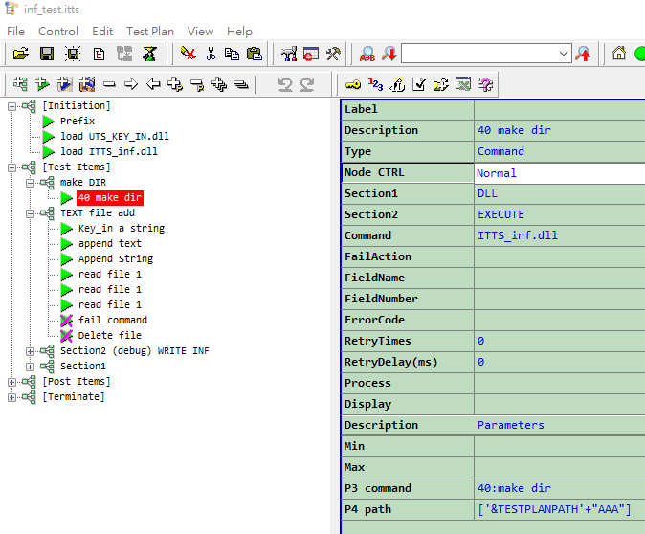

Example:30:Delete file

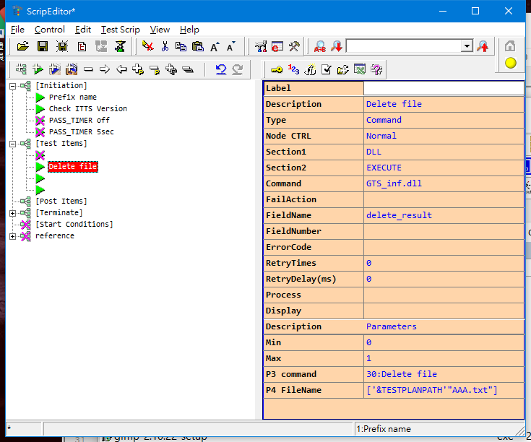

<Item>

<Text> </Text>

<Description> Delete file</Description>

<ItemType> 2</ItemType>

<Skip> 1</Skip>

<ItemSection1> DLL</ItemSection1>

<ItemSection2> EXECUTE</ItemSection2>

<ItemCommand> GTS_inf.dll</ItemCommand>

<FailAction> </FailAction>

<FieldName> delete_result</FieldName>

<FieldNumber> </FieldNumber>

<ErrorCode> </ErrorCode>

<RetryTimes> 0</RetryTimes>

<RetryDelay> 0</RetryDelay>

<Process> </Process>

<FieldType> </FieldType>

<Parameter>

<i1>

<Content>0</Content>

<Description>Min</Description>

</i1>

<i2>

<Content>1</Content>

<Description>Max</Description>

</i2>

<i3>

<Content>30:Delete file</Content>

<Description>P3 command</Description>

</i3>

<i4>

<Content>['&TESTPLANPATH'"AAA.txt"]</Content>

<Description>P4 FileName</Description>

</i4>

</Parameter>

</Item>

Example: File access speed test suggest 100k file

<Item>

<Text> </Text>

<Description> file access time e:</Description>

<ItemType> 2</ItemType>

<Skip> 1</Skip>

<ItemSection1> DLL</ItemSection1>

<ItemSection2> EXECUTE</ItemSection2>

<ItemCommand> ITTS_inf.dll</ItemCommand>

<FailAction> </FailAction>

<FieldName> speed(kB/S);D_T</FieldName>

<FieldNumber> 8;9</FieldNumber>

<ErrorCode> Err001</ErrorCode>

<RetryTimes> 0</RetryTimes>

<RetryDelay> 0</RetryDelay>

<Process> </Process>

<FieldType> </FieldType>

<Parameter>

<i1>

<Content></Content>

<Description>Min</Description>

</i1>

<i2>

<Content></Content>

<Description>Max</Description>

</i2>

<i3>

<Content>22:accesstime</Content>

<Description>P3 command</Description>

</i3>

<i4>

<Content>["e:\Test.txt"]</Content>

<Description>P4 FileName</Description>

</i4>

<i5>

<Content>0</Content>

<Description>cache1 or without0</Description>

</i5>

<i6>

<Content>2</Content>

<Description>test time for avg</Description>

</i6>

<i7>

<Content>1</Content>

<Description>skip first time</Description>

</i7>

<i8>

<Content></Content>

<Description>nil</Description>

</i8>

<i9>

<Content></Content>

<Description>format string</Description>

</i9>

<i10>

<Content>1</Content>

<Description>debug mode</Description>

</i10>

</Parameter>

</Item>

to test USB or HDD

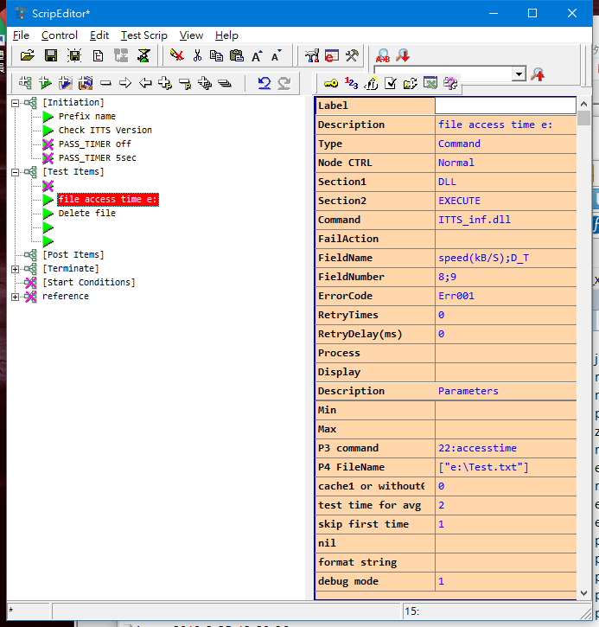

Example access time of c drive

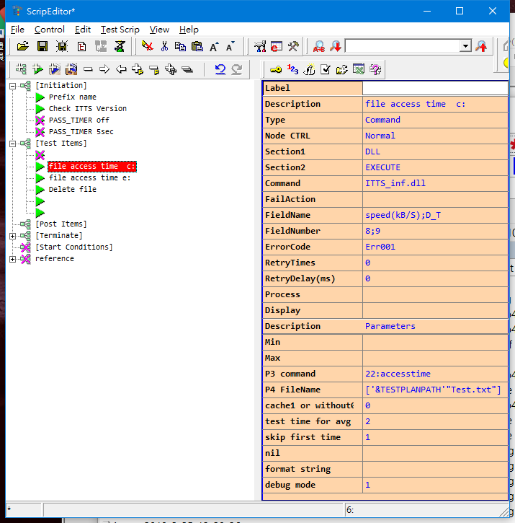

<Item>

<Text> </Text>

<Description> file access time c:</Description>

<ItemType> 2</ItemType>

<Skip> 1</Skip>

<ItemSection1> DLL</ItemSection1>

<ItemSection2> EXECUTE</ItemSection2>

<ItemCommand> ITTS_inf.dll</ItemCommand>

<FailAction> </FailAction>

<FieldName> speed(kB/S);D_T</FieldName>

<FieldNumber> 8;9</FieldNumber>

<ErrorCode> Err001</ErrorCode>

<RetryTimes> 0</RetryTimes>

<RetryDelay> 0</RetryDelay>

<Process> </Process>

<FieldType> </FieldType>

<Parameter>

<i1>

<Content></Content>

<Description>Min</Description>

</i1>

<i2>

<Content></Content>

<Description>Max</Description>

</i2>

<i3>

<Content>22:accesstime</Content>

<Description>P3 command</Description>

</i3>

<i4>

<Content>['&TESTPLANPATH'"Test.txt"]</Content>

<Description>P4 FileName</Description>

</i4>

<i5>

<Content>0</Content>

<Description>cache1 or without0</Description>

</i5>

<i6>

<Content>2</Content>

<Description>test time for avg</Description>

</i6>

<i7>

<Content>1</Content>

<Description>skip first time</Description>

</i7>

<i8>

<Content></Content>

<Description>nil</Description>

</i8>

<i9>

<Content></Content>

<Description>format string</Description>

</i9>

<i10>

<Content>1</Content>

<Description>debug mode</Description>

</i10>

</Parameter>

</Item>

|  |  |  |  |  |  |  |  |  |  |
| --- | --- | --- | --- | --- | --- | --- | --- | --- | --- |
| ***21: read file*** | | | | | | | | |  |
| ***P1 (Min)*** | P2 (Max) | P3 (command) | P4  ( INF File Name ) | P5  start line | P6  end line | P7  leading string | P8  end_string | P9  Format string | P10  Debug |
|  |  | **21:** **read file** | **['&TESTPLANPATH'"AAA.txt"]** | Num or nil | Num or nil | String or nil  To remove the leading string | String or nil  To remove end string. | String o*r* nil | 1 or nil |
|  |  |  |  |  |  |  |  |  |  |

Example code:

How to use example:

Select all (ctrl-a) in one of block below.

Copy (ctrl-c) them to clipboard.

Paste (ctrl-v) to UTS test plan tree area.

Example 21:read file

<Item>

<Text> </Text>

<Description> read file 1</Description>

<ItemType> 2</ItemType>

<Skip> 1</Skip>

<ItemSection1> DLL</ItemSection1>

<ItemSection2> EXECUTE</ItemSection2>

<ItemCommand> GTS_inf.dll</ItemCommand>

<FailAction> </FailAction>

<FieldName> r1;r2;r3;r4;r5;r6;r7;</FieldName>

<FieldNumber> 8;9;10;11;12;13;14;</FieldNumber>

<ErrorCode> Err001</ErrorCode>

<RetryTimes> 0</RetryTimes>

<RetryDelay> 0</RetryDelay>

<Process> </Process>

<FieldType> </FieldType>

<Parameter>

<i1>

<Content></Content>

<Description>Min</Description>

</i1>

<i2>

<Content></Content>

<Description>Max</Description>

</i2>

<i3>

<Content>21:read file</Content>

<Description>P3 command</Description>

</i3>

<i4>

<Content>['&TESTPLANPATH'"AAA.txt"]</Content>

<Description>P4 FileName</Description>

</i4>

<i5>

<Content></Content>

<Description>start line</Description>

</i5>

<i6>

<Content></Content>

<Description>end line</Description>

</i6>

<i7>

<Content></Content>

<Description>leading string</Description>

</i7>

<i8>

<Content></Content>

<Description>end_string</Description>

</i8>

<i9>

<Content>s([all];)</Content>

<Description>format string</Description>

</i9>

</Parameter>

</Item>

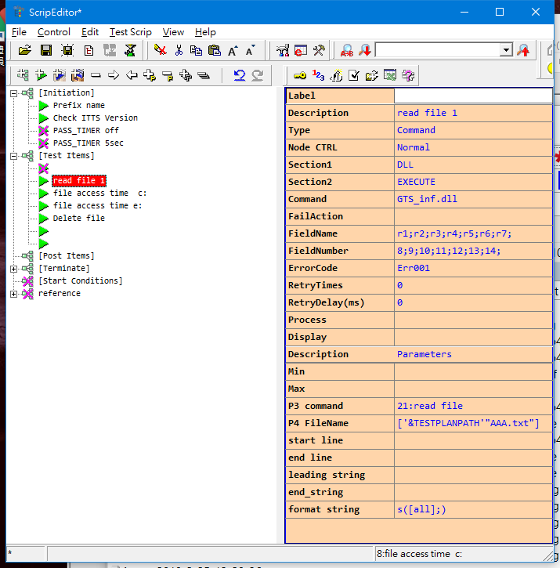

Example 21:read file (multi fileld)

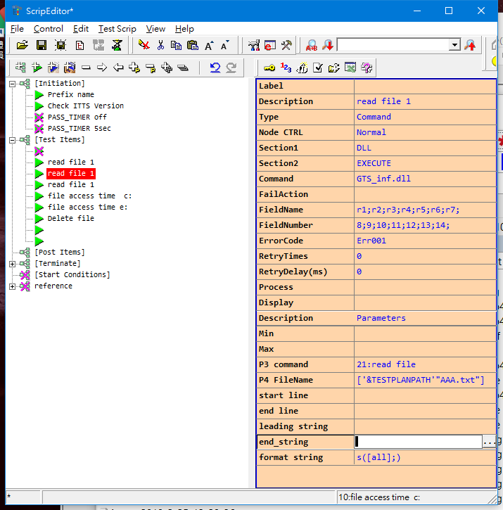

<Item>

<Text> </Text>

<Description> read file 1</Description>

<ItemType> 2</ItemType>

<Skip> 1</Skip>

<ItemSection1> DLL</ItemSection1>

<ItemSection2> EXECUTE</ItemSection2>

<ItemCommand> GTS_inf.dll</ItemCommand>

<FailAction> </FailAction>

<FieldName> r1;r2;r3;r4;r5;r6;r7;</FieldName>

<FieldNumber> 8;9;10;11;12;13;14;</FieldNumber>

<ErrorCode> Err001</ErrorCode>

<RetryTimes> 0</RetryTimes>

<RetryDelay> 0</RetryDelay>

<Process> </Process>

<FieldType> </FieldType>

<Parameter>

<i1>

<Content></Content>

<Description>Min</Description>

</i1>

<i2>

<Content></Content>

<Description>Max</Description>

</i2>

<i3>

<Content>21:read file</Content>

<Description>P3 command</Description>

</i3>

<i4>

<Content>['&TESTPLANPATH'"AAA.txt"]</Content>

<Description>P4 FileName</Description>

</i4>

<i5>

<Content></Content>

<Description>start line</Description>

</i5>

<i6>

<Content></Content>

<Description>end line</Description>

</i6>

<i7>

<Content></Content>

<Description>leading string</Description>

</i7>

<i8>

<Content></Content>

<Description>end_string</Description>

</i8>

<i9>

<Content>s([all])</Content>

<Description>format string</Description>

</i9>

</Parameter>

</Item>

Example 21:Read file start form line n0 search to line n1

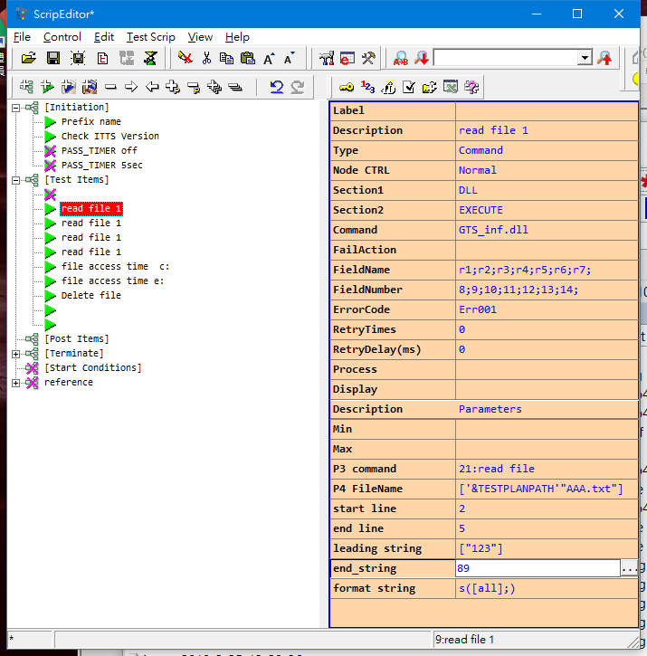

<Item>

<Text> </Text>

<Description> read file 1</Description>

<ItemType> 2</ItemType>

<Skip> 1</Skip>

<ItemSection1> DLL</ItemSection1>

<ItemSection2> EXECUTE</ItemSection2>

<ItemCommand> GTS_inf.dll</ItemCommand>

<FailAction> </FailAction>

<FieldName> r1;r2;r3;r4;r5;r6;r7;</FieldName>

<FieldNumber> 8;9;10;11;12;13;14;</FieldNumber>

<ErrorCode> Err001</ErrorCode>

<RetryTimes> 0</RetryTimes>

<RetryDelay> 0</RetryDelay>

<Process> </Process>

<FieldType> </FieldType>

<Parameter>

<i1>

<Content></Content>

<Description>Min</Description>

</i1>

<i2>

<Content></Content>

<Description>Max</Description>

</i2>

<i3>

<Content>21:read file</Content>

<Description>P3 command</Description>

</i3>

<i4>

<Content>['&TESTPLANPATH'"AAA.txt"]</Content>

<Description>P4 FileName</Description>

</i4>

<i5>

<Content>2</Content>

<Description>start line</Description>

</i5>

<i6>

<Content>5</Content>

<Description>end line</Description>

</i6>

<i7>

<Content>["123"]</Content>

<Description>leading string</Description>

</i7>

<i8>

<Content>89</Content>

<Description>end_string</Description>

</i8>

<i9>

<Content>s([all];)</Content>

<Description>format string</Description>

</i9>

</Parameter>

</Item>

41:get File info

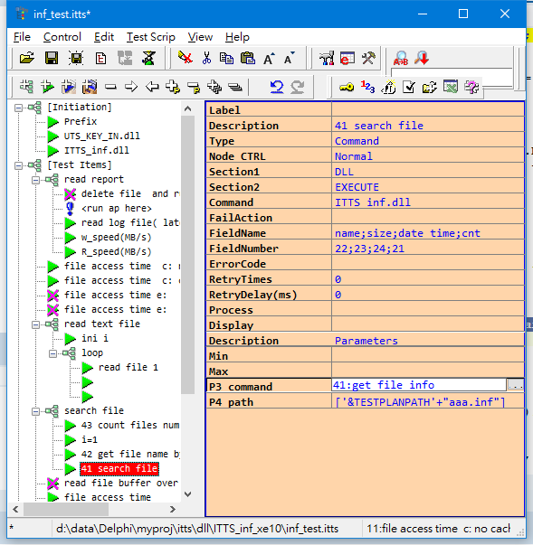

<Item>

<Text> </Text>

<Description> 41 search file</Description>

<ItemType> 2</ItemType>

<Skip> 1</Skip>

<ItemSection1> DLL</ItemSection1>

<ItemSection2> EXECUTE</ItemSection2>

<ItemCommand> ITTS_inf.dll</ItemCommand>

<FailAction> </FailAction>

<FieldName> name;size;date_time;cnt</FieldName>

<FieldNumber> 22;23;24;21</FieldNumber>

<ErrorCode> </ErrorCode>

<RetryTimes> 0</RetryTimes>

<RetryDelay> 0</RetryDelay>

<Process> </Process>

<FieldType> </FieldType>

<Parameter>

<i1>

<Content></Content>

<Description>Min</Description>

</i1>

<i2>

<Content></Content>

<Description>Max</Description>

</i2>

<i3>

<Content>41:get file info</Content>

<Description>P3 command</Description>

</i3>

<i4>

<Content>['&TESTPLANPATH'+"aaa.inf"]</Content>

<Description>P4 path</Description>

</i4>

</Parameter>

</Item>

43: count files

Use **dir *.txt** similar way to count number of files in such directory.

Returen count number

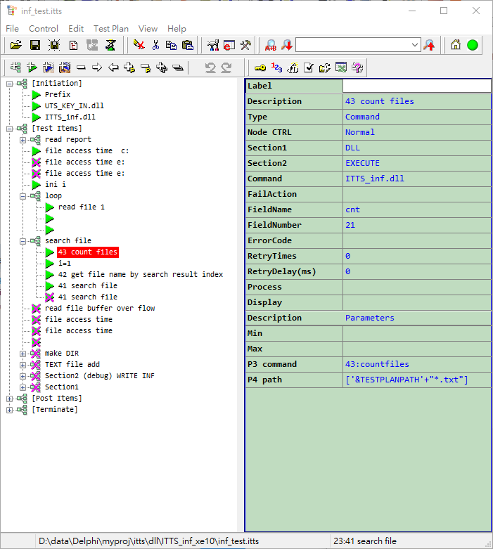

<Item>

<Text> </Text>

<Description> 43 count files</Description>

<ItemType> 2</ItemType>

<Skip> 1</Skip>

<ItemSection1> DLL</ItemSection1>

<ItemSection2> EXECUTE</ItemSection2>

<ItemCommand> ITTS_inf.dll</ItemCommand>

<FailAction> </FailAction>

<FieldName> cnt</FieldName>

<FieldNumber> 21</FieldNumber>

<ErrorCode> </ErrorCode>

<RetryTimes> 0</RetryTimes>

<RetryDelay> 0</RetryDelay>

<Process> </Process>

<FieldType> </FieldType>

<Parameter>

<i1>

<Content></Content>

<Description>Min</Description>

</i1>

<i2>

<Content></Content>

<Description>Max</Description>

</i2>

<i3>

<Content>43:countfiles</Content>

<Description>P3 command</Description>

</i3>

<i4>

<Content>['&TESTPLANPATH'+"*.txt"]</Content>

<Description>P4 path</Description>

</i4>

</Parameter>

</Item>

42: get file name by search result index

Work with 43

First use 43 command to count total files which match the search criteria.

Then use index to get file name by this search criteria.

Return file name, file size, file datetime yyyymmddhhmmss.zzz

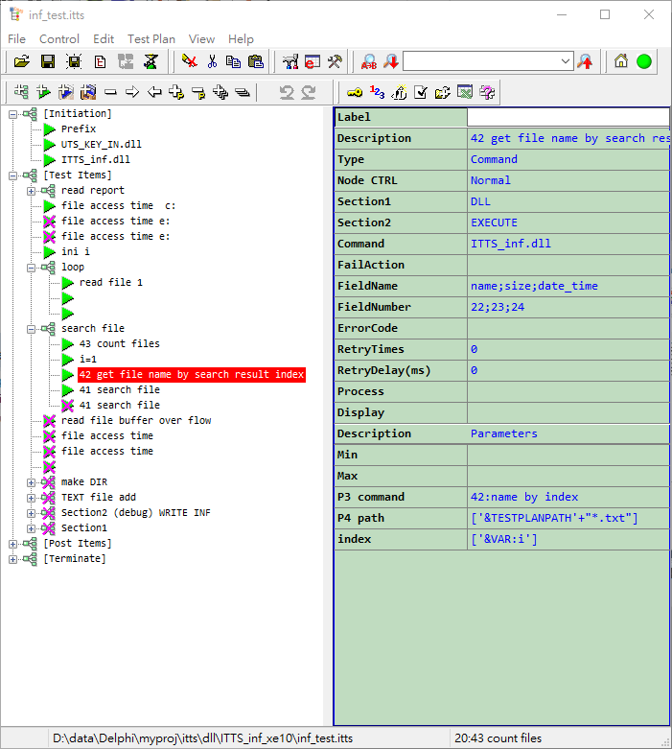

<Item>

<Text> </Text>

<Description> i=1</Description>

<ItemType> 2</ItemType>

<Skip> 1</Skip>

<ItemSection1> variable</ItemSection1>

<ItemSection2> i</ItemSection2>

<ItemCommand> =</ItemCommand>

<FailAction> </FailAction>

<FieldName> </FieldName>

<FieldNumber> </FieldNumber>

<ErrorCode> </ErrorCode>

<RetryTimes> 0</RetryTimes>

<RetryDelay> 0</RetryDelay>

<Process> </Process>

<FieldType> </FieldType>

<Parameter>

<i1>

<Content></Content>

<Description>Min</Description>

</i1>

<i2>

<Content></Content>

<Description>Max</Description>

</i2>

<i3>

<Content>1</Content>

<Description>Value3</Description>

</i3>

</Parameter>

</Item>

<Item>

<Text> </Text>

<Description> 42 get file name by search result index</Description>

<ItemType> 2</ItemType>

<Skip> 1</Skip>

<ItemSection1> DLL</ItemSection1>

<ItemSection2> EXECUTE</ItemSection2>

<ItemCommand> ITTS_inf.dll</ItemCommand>

<FailAction> </FailAction>

<FieldName> name;size;date_time</FieldName>

<FieldNumber> 22;23;24</FieldNumber>

<ErrorCode> </ErrorCode>

<RetryTimes> 0</RetryTimes>

<RetryDelay> 0</RetryDelay>

<Process> </Process>

<FieldType> </FieldType>

<Parameter>

<i1>

<Content></Content>

<Description>Min</Description>

</i1>

<i2>

<Content></Content>

<Description>Max</Description>

</i2>

<i3>

<Content>42:name by index</Content>

<Description>P3 command</Description>

</i3>

<i4>

<Content>['&TESTPLANPATH'+"*.txt"]</Content>

<Description>P4 path</Description>

</i4>

<i5>

<Content>['&VAR:i']</Content>

<Description>index</Description>

</i5>

</Parameter>

</Item>

Example 80:hex_to_float

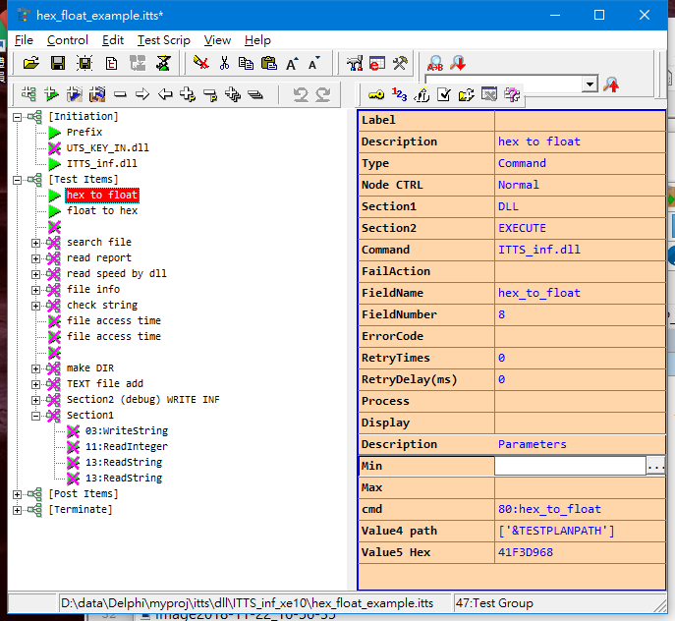

<Item>

<Text> </Text>

<Description> hex to float</Description>

<ItemType> 2</ItemType>

<Skip> 1</Skip>

<ItemSection1> DLL</ItemSection1>

<ItemSection2> EXECUTE</ItemSection2>

<ItemCommand> ITTS_inf.dll</ItemCommand>

<FailAction> </FailAction>

<FieldName> hex_to_float</FieldName>

<FieldNumber> 8</FieldNumber>

<ErrorCode> </ErrorCode>

<RetryTimes> 0</RetryTimes>

<RetryDelay> 0</RetryDelay>

<Process> </Process>

<FieldType> </FieldType>

<Parameter>

<i1>

<Content></Content>

<Description>Min</Description>

</i1>

<i2>

<Content></Content>

<Description>Max</Description>

</i2>

<i3>

<Content>80:hex_to_float</Content>

<Description>cmd</Description>

</i3>

<i4>

<Content>['&TESTPLANPATH']</Content>

<Description>Value4 path</Description>

</i4>

<i5>

<Content>41F3D968</Content>

<Description>Value5 Hex</Description>

</i5>

</Parameter>

</Item>

Example 81:Single_to_hex

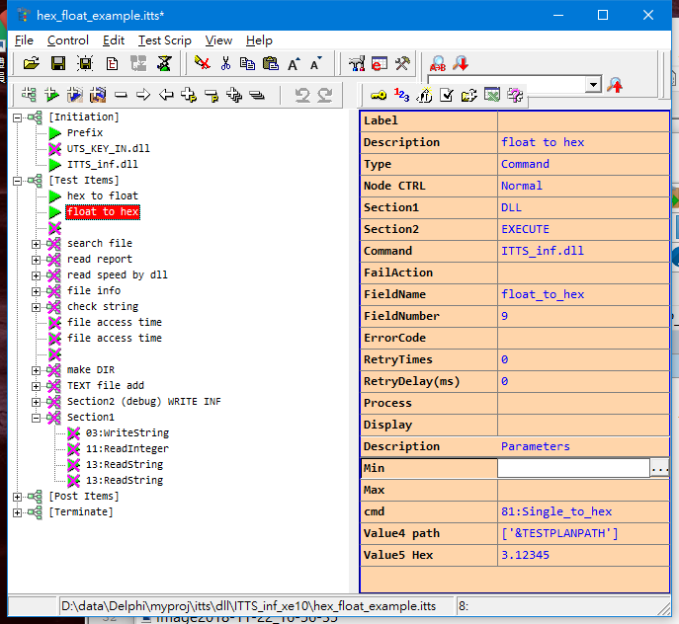

<Item>

<Text> </Text>

<Description> float to hex</Description>

<ItemType> 2</ItemType>

<Skip> 1</Skip>

<ItemSection1> DLL</ItemSection1>

<ItemSection2> EXECUTE</ItemSection2>

<ItemCommand> ITTS_inf.dll</ItemCommand>

<FailAction> </FailAction>

<FieldName> float_to_hex</FieldName>

<FieldNumber> 9</FieldNumber>

<ErrorCode> </ErrorCode>

<RetryTimes> 0</RetryTimes>

<RetryDelay> 0</RetryDelay>

<Process> </Process>

<FieldType> </FieldType>

<Parameter>

<i1>

<Content></Content>

<Description>Min</Description>

</i1>

<i2>

<Content></Content>

<Description>Max</Description>

</i2>

<i3>

<Content>81:Single_to_hex</Content>

<Description>cmd</Description>

</i3>

<i4>

<Content>['&TESTPLANPATH']</Content>

<Description>Value4 path</Description>

</i4>

<i5>

<Content>3.12345</Content>

<Description>Value5 Hex</Description>

</i5>

</Parameter>

</Item>